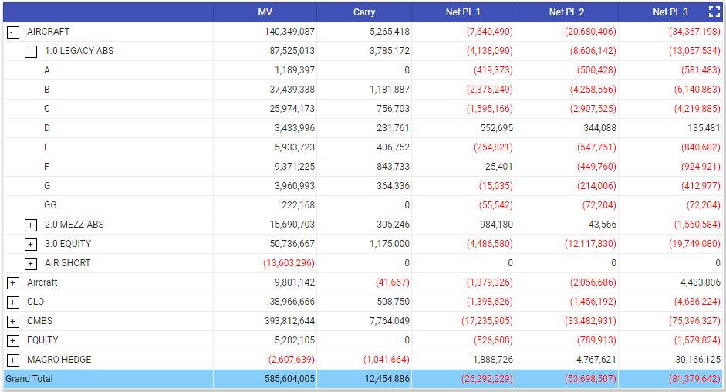

Create a pivot table with two level grouping with the attached JSON. By default, all the columns should have group level “SUM” values at root level. And the grand total should have the SUM of all the rows.